**How to declare the variable**

**1. Declaration**: Variables in JavaScript are declared using the var, let, or const keywords.

**var:** Historically used for variable declaration in JavaScript. Variables declared with var are function-scoped or globally scoped.

**let**: Introduced in ECMAScript 6 (ES6). Variables declared with let have block scope, meaning they are limited to the block (enclosed by curly braces) in which they are defined.

**const:** Also introduced in ES6. Constants declared with const have block scope like let, but their values cannot be reassigned once they are initialized.

1. **Initialization**: Variables can be declared and initialized at the same time.

**Examples**:-



1. **Variable Dynamic Typing:** JavaScript is dynamically typed, meaning you don't have to specify the data type of a variable when declaring it. The type of the variable can change during the execution of the program.



1. **Naming:** Variable names in JavaScript must begin with a letter (a-z, A-Z), underscore (_), or dollar sign ($). They can also contain numbers (0-9), but cannot start with a number. Variable names are case-sensitive.
2. **Scope:** Variables in JavaScript have function-level scope (if declared with **var**) or block-level scope (if declared with **let** or **const**).

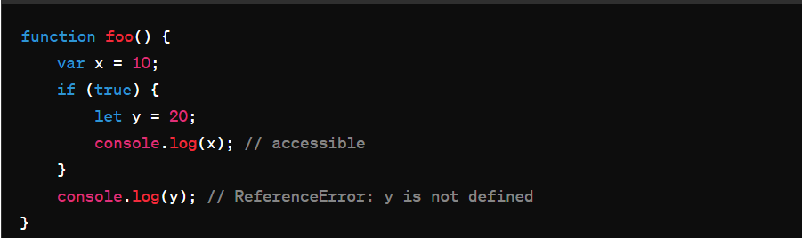

1. **Hoisting:** Variable declarations (not initialization) are hoisted to the top of their containing scope. This means you can access a variable before it's declared, but it will have an initial value of undefined.

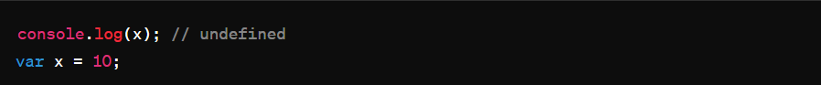

1. **Global Variables**: Variables declared outside of any function or block have global scope and can be accessed from anywhere in the code.
2. **Constants**: Constants declared with **const** cannot be reassigned a new value once initialized.

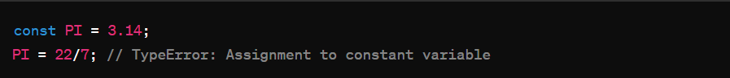

1. **Mutable vs. Immutable**: While variables declared with **var** and **let** are mutable (their values can be changed), constants declared with **const** are immutable (their values cannot be changed after initialization)